
UNIVERSITY EXAMINATIONS
EXAMINATION FOR JANUARY / APRIL 2024/2025 DIPLOMA IN COMPUTER SCIENCE/DIPLOMA IN INFORMATION TECHNOLOGY/DIPLOMA IN BUSINESS INFORMATION TECHNOLOGY/DIPLOMA IN CYBER SECURITY
RCS 016 / RCT 003: INTRODUCTION TO DIGITAL ELECTRONICS.

DATE 9TH APRIL 2025 TIME: 2 HOURS
GENERAL INSTRUCTIONS:
Students are NOT permitted to write on the examination question paper during examination time.
This is a closed book examination. Text book/Reference books/notes are not permitted.

SPECIAL INSTRUCTIONS:
This examination paper consists Questions in Section A followed by section B.
Answer Question 1 and any Other Two questions.
QUESTIONS in ALL Sections should be answered in answer booklet(s).

PLEASE start the answer to EACH question on a NEW PAGE.

Keep your phone(s) switched off at the front of the examination room.

Keep ALL bags and caps at the front of the examination room and DO NOT refer to ANY unauthorized material during the course of the examination.

ALWAYS show your working.

Marks indicated in parenthesis i.e. ( ) will be awarded for clear and logical answers.

Write your REGISTRATION No. clearly on the answer booklet(s).

For the Questions, write the number of the question on the answer booklet cover page in the order you answered them.
- DO NOT use your PHONE as a CALCULATOR.
- YOU are ONLY ALLOWED to leave the exam room 1 hour to the end of the Exam.
- DO NOT write on the QUESTION PAPER. Use the back of your BOOKLET for any calculations or rough work.
- Scientific CALCULATOR will be required.
SECTION A (COMPULSORY)
Question (1) - (30Marks)
- Describe the following terms as used in digital logics. (6 Marks)
- A.D.C.
- D.A.C.
- Encoders.
- Decoders.
- Digital Signals.
- Analog Signals.
- Express the circuit below as a Boolean function. (4 Marks)
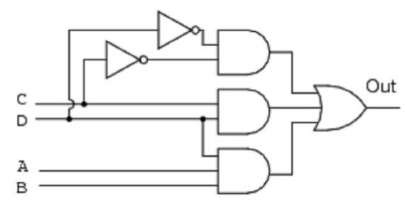
- Which units of measurement are used to express the following electrical quantities. (6 Marks)
- Power.
- Current.
- Frequency.
- Resistance.
- Magnetic flux.
- Potential difference.

- Considering the Boolean function shown below, draw an equivalent Logic circuit diagram.
$Y_{o} =\left(A+B\right)C+ \overline{B}\left( A+\overline{C} \right)+\left(\overline{A}B\overline{C}\right)$ (4 Marks)

- Convert the following binary numbers, into Decimal Number. (3 Marks)
10101010.010101₂ Show all the working.
- Convert the following Decimal numbers, into Binary Number. (3 Marks)
123.456₁₀ Show all the working.

- Design a half adder from the first principle of digital circuit designing. (4 Marks)

SECTION B (ANSWER ANY TWO QUESTIONS)

Question (2) - (15Marks)

- Considering the logic circuit below:

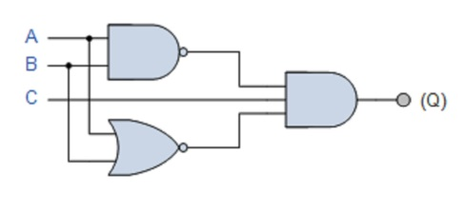
- Derive Boolean function output (Q). (3 Marks)
- Derive a truth table indicating all possible inputs (A, B & C) and outputs (Q) for each and every possible output. (3 Marks)

- The modern computers are able to process both digital and analog signals/data. Discuss how this is achieved in voice processing, for example in mobile phone devices or computers systems. (4 Marks)

- State the De-Morgan’s theorems. (1 Marks)

- Using suitable truth tables; prove the De-Morgan’s theorems. (4 Marks)

Question (3) - (15 Marks)
- Evaluate the following numbers Conversions, into the indicate formats.
NB: Show all the working, marks awarded on only working, not answers. (10 Marks)

- 11101010110011010_{bin} into hexadecimal number.
- 1101010100_{bin} into decimal number.
- 10101_{dec} into binary number.
- 8A0BC_{hex} into octal number.
- 10101010_{bin} into gray code.

- Compare encoders and decoders. (2 Marks)

- Digital logic circuits require simplification after designing using any appropriate method like Boolean Simplification or Karnaugh Mapping technique. Justify by giving THREE reasons. (3 Marks)

Question (4) - (15 Marks)
- Most of computer devices and digital systems, use DC Power rather that AC Power;
Using suitable electronics circuit, explain how the rectifiers operated to achieve AC to DC conversion. (5 Marks)

- Design a Three Bits Binary to Gray code converter, considering first principle designing. (7 Marks)

- Describe the following digital logic circuits / functions, and state how they are used in computers / Digital Systems. (3 Marks)
- Multiplexer.
- Full adder.
- Counters.

Question (5) - (15 Marks)
- With references to digital logic gates, Name FIVE basic gates, draw each symbol and derive the truth tables for each. (5 Marks)

- Implement the following logic gates using a suitable universal gate.

- NOT gate. (1 Marks)
- AND gate. (2 Marks)
- OR gate. (3 Marks)

- Considering the logic circuit diagram below, derive the output function (Q). (5 Marks)

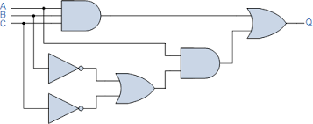

END

